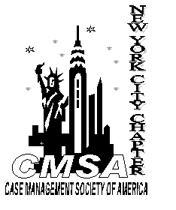
PLEASE POST

Case Management Society of America
New York City Chapter Meeting


Topic: Cancer Survivorship

Speaker: TBA

When: October 14, 2015
5:30 to 6pm Registration & Networking

6 to 8:00pm presentation

Where: The Marriott Marquis Hotel
45th Street and Broadway

Fee: CMSA A Members – $35.00
CMSA B Members – $45.00
Non-members - $55.00
At the door (no pre-registration) - $50-$75.00
Sorry, there are no transfers, refunds or credits for future meetings
given in the event that a person is unable to attend

RSVP: October 12 –on the website
For More Info: www.cmsa-nyc.org
Sponsored By:


